5.2 Prepare: MySQL — Create, Insert, Update, Drop, Index

1. script or commands used to create temp3

1. script or commands used to populate temp3

script or commands used to populate color.

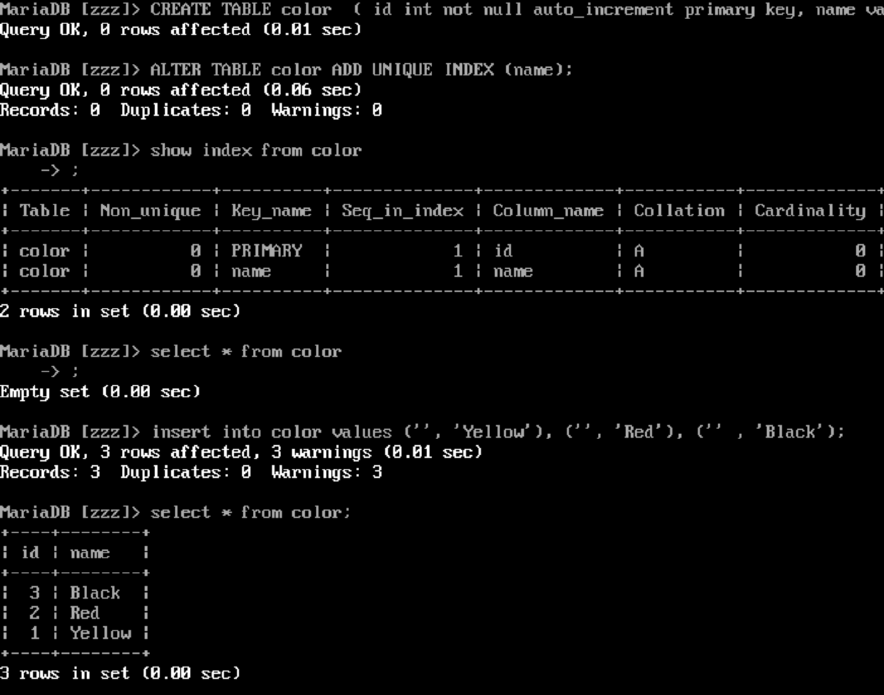

populate the colorid column in temp3.

the results of displaying the contents of temp3 and of color

